17.88: a) The lost volume, 2.6 L, is the difference between the expanded volume of the fuel and the tanks, and the maximum temperature difference is
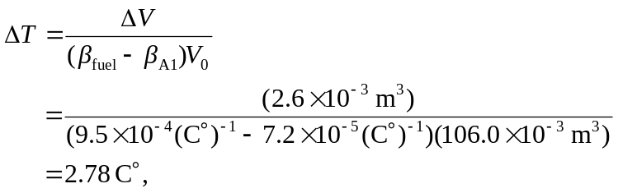
or 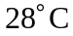 to two figures; the maximum temperature was 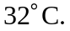 b) No fuel can spill if the tanks are filled just before takeoff.

